Capstone Project Final Report

Submitted to
Faculty of Engineering and Natural Sciences
Department of Computer Engineering

In partial fulfillment of the requirements for the degree
BACHELOR of SCIENCE in COMPUTER ENGINEERING

MULTIMODAL DEEP LEARNING SYSTEM FOR EMOTION RECOGNITION USING AUDIO, VIDEO, AND TEXT DATA

Students / ID Numbers:
Berk Emre Sarı / 220901555
Kaan Bünyamin Alemdar / 210901043
Tayyip Cebbar / 229920276

Supervisor(s): Asst. Prof. Wadhah Zeyad Tareq AL GBARI

Istanbul
$Dec 2025$
STUDENT DECLARATION

By submitting this report, as partial fulfillment of the requirements of the Capstone Project, the students promise on penalty of failure of the course that
- They have given credit to and declared (by citation), any work that is not their own (e.g. parts of the report that is copied/pasted from the Internet, design or construction performed by another person, etc.),
- They have not received unpermitted aid for the project design, construction, report or presentation,
- They have not falsely assigned credit for work to another student in the group, and not take credit for work done by another student in the group.

Abstract
Emotion recognition has become a central research topic in affective computing due to its significant impact on human–computer interaction systems. Human emotions are expressed through multiple modalities, including speech characteristics, facial expressions, and linguistic content. As a result, emotion recognition is inherently a multimodal problem that cannot be effectively addressed using single-modality approaches.
This study presents a multimodal deep learning system for emotion recognition by integrating audio, video, and text data within a unified framework. The proposed system processes speech signals, facial expressions, and transcribed textual content through parallel modality-specific pipelines. Deep learning models are employed for feature extraction in each modality, while statistical and probabilistic fusion techniques are used to combine multimodal representations for final emotion classification. The system is designed to improve robustness, accuracy, and efficiency compared to unimodal approaches. Experimental evaluations demonstrate the effectiveness of the proposed framework in recognizing emotional states, highlighting its potential applications in intelligent and emotion-aware human–computer interaction systems.

Keywords
Emotion Recognition; Multimodal Deep Learning; Audio-Visual Processing; Natural Language Processing; Affective Computing

Table of Contents
Section 1: Introduction ................................................................................................................10
1.1 Motivation ..........................................................................................................................10
1.2 Problem Definition ............................................................................................................11
1.2.1 Research Problem .........................................................................................................11
1.3 Objectives of the Study ......................................................................................................11
1.3.1 Specific Objectives .......................................................................................................11
1.4 Scope of the Study ..............................................................................................................11
1.5 Structure of the Report ......................................................................................................12
Section 2: Literature Review .......................................................................................................14
2.1 Unimodal Emotion Recognition Approaches ..................................................................14
2.1.1 Audio-Based Emotion Recognition ..............................................................................14
2.2 Visual-Based Emotion Recognition ..................................................................................14
2.2.1 Deep Learning for Facial Expression Analysis .............................................................14
2.3 Text-Based Emotion Recognition .....................................................................................15
2.3.1 Natural Language Processing Techniques ....................................................................15
2.4 Deep Learning in Emotion Recognition ...........................................................................15
2.4.1 Advantages of Deep Learning Models ..........................................................................15
2.5 Multimodal Emotion Recognition ....................................................................................15
2.5.1 Multimodal Fusion Strategies .......................................................................................16
2.6 Research Gap and Motivation ..........................................................................................16
2.6.1 Contribution of This Study ............................................................................................16
Section 3: Methodology ...............................................................................................................18
3.1 System Overview ................................................................................................................18
3.1.1 Overall Architecture Design .........................................................................................19
3.2 Data Acquisition and Preprocessing .................................................................................19
3.2.1 Audio Data Preprocessing .............................................................................................20
3.3 Audio-Based Emotion Recognition Pipeline ....................................................................20
3.3.1 Feature Extraction from Audio Signals .........................................................................20
3.3.2 Audio Deep Learning Model ........................................................................................20
3.4 Video-Based Emotion Recognition Pipeline ....................................................................21
3.4.1 Face Detection and Frame Processing ...........................................................................21
3.4.2 Visual Feature Extraction and Modeling .......................................................................21
3.5 Text-Based Emotion Recognition Pipeline .......................................................................21
3.5.1 Speech-to-Text Conversion ..........................................................................................22
3.5.2 Text Representation and Classification .........................................................................22
3.6 Multimodal Fusion Strategy .............................................................................................22
3.6.1 Fusion Levels ................................................................................................................23
3.6.2 Fusion and Classification Module .................................................................................23
3.7 Training Procedure ...........................................................................................................23
3.7.1 Model Optimization ......................................................................................................23
3.8 Evaluation Metrics ............................................................................................................23
3.8.1 Performance Measures .................................................................................................24
Section 4: Results .........................................................................................................................26
4.1 Experimental Setup ...........................................................................................................26
4.1.1 Implementation Details .................................................................................................26
4.2 Unimodal Performance Analysis ......................................................................................26
4.2.1 Audio-Based Emotion Recognition Results ..................................................................27
4.2.2 Video-Based Emotion Recognition Results ..................................................................27
4.2.3 Text-Based Emotion Recognition Results ....................................................................27
4.3 Multimodal Emotion Recognition Results .......................................................................27
4.3.1 Performance Comparison .............................................................................................28
4.4 Evaluation Metrics and Analysis ......................................................................................28
4.4.1 Quantitative Results ......................................................................................................29
4.4.2 Error Analysis ...............................................................................................................29
4.5 Summary of Results ...........................................................................................................30
Section 5: Discussion and Conclusion ........................................................................................32
5.1 Discussion of Results ..........................................................................................................32
5.1.1 Comparison with Existing Studies ................................................................................32
5.2 Contributions of the Study ................................................................................................32
5.2.1 Technical Contributions ...............................................................................................33
5.2.2 Practical Contributions .................................................................................................33
5.3 Limitations .........................................................................................................................33
5.3.1 Dataset and Generalization Limitations ........................................................................33
5.4 Future Work ......................................................................................................................33
5.4.1 System Extensions ........................................................................................................34
5.5 Conclusion ..........................................................................................................................34
Acknowledgement .......................................................................................................................35
Appendix ......................................................................................................................................36
References ....................................................................................................................................37

List of Tables
Table 1. Comparison of unimodal and multimodal emotion recognition methods.........................19
Table 2. Classification performance of unimodal emotion recognition models.............................26
Table 3. Performance metrics of the proposed multimodal emotion recognition system...............28
Table 4. Confusion matrix of the multimodal emotion recognition system....................................29

List of Figures
Fig. 1. Overall architecture of the proposed multimodal emotion recognition system....................18
Fig. 2. Audio-based emotion recognition pipeline..........................................................................20
Fig. 3. Video-based emotion recognition pipeline..........................................................................21
Fig. 4. Text-based emotion recognition pipeline............................................................................21
Fig. 5. Multimodal fusion and classification framework................................................................22
Fig. 6. Performance comparison of unimodal and multimodal emotion recognition models..........27
Fig. 7. Performance comparison of different multimodal fusion strategies....................................28
Fig. 8. Confusion matrix visualization of the proposed multimodal emotion recognition system..29

List of Abbreviations
ASR | Automatic Speech Recognition
CNN  DNN  F1  HCI  LSTM  MFCC  NLP  RNN | Convolutional Neural Network  Deep Neural Network  F1-Score  Human–Computer Interaction  Long Short-Term Memory  Mel-Frequency Cepstral Coefficients  Natural Language Processing  Recurrent Neural Network

Section 1:
Introduction

Introduction
Emotion recognition refers to the process of identifying and interpreting human emotional states through computational methods. In recent years, it has gained increasing attention due to its wide range of applications in human–computer interaction, healthcare systems, intelligent virtual assistants, education technologies, and social robotics. The ability of machines to understand human emotions enables more natural, adaptive, and effective interaction between humans and intelligent systems.
Human emotions are complex and are expressed through various channels simultaneously. Speech intonation, facial expressions, body language, and linguistic content all contribute to emotional communication. Traditional emotion recognition systems have largely focused on single modalities, such as facial expression analysis or speech emotion recognition. While these systems have achieved moderate success under controlled conditions, their performance significantly degrades in real-world environments due to noise, ambiguity, and incomplete information.
The emergence of deep learning has significantly advanced the field of emotion recognition by enabling automatic feature extraction and modeling of complex patterns from large-scale data. However, unimodal deep learning models remain limited in their ability to capture the full emotional context. Consequently, multimodal approaches that integrate complementary information from multiple sources have become a prominent research direction.
This project focuses on the design and implementation of a multimodal deep learning system that combines audio, video, and text data for emotion recognition. By leveraging parallel processing and multimodal fusion strategies, the proposed system aims to achieve higher accuracy, robustness, and efficiency compared to unimodal approaches.

Motivation
The motivation behind this study arises from the limitations of existing unimodal emotion recognition systems and the growing demand for emotionally intelligent machines. In real-world applications, relying on a single modality often leads to misclassification due to environmental factors such as background noise, lighting variations, or ambiguous language.
Multimodal emotion recognition offers a promising solution by combining complementary emotional cues from different data sources. For example, facial expressions can provide visual indicators of emotion, while speech prosody and textual semantics offer additional context. Integrating these modalities can significantly enhance system reliability and robustness.

Problem Definition
Despite advancements in deep learning, designing an effective multimodal emotion recognition system presents several challenges. These include synchronization of heterogeneous data streams, efficient feature extraction, and effective fusion of multimodal representations. Additionally, processing audio, video, and text data simultaneously introduces computational complexity, which must be addressed to enable real-time or near real-time performance.

Research Problem
The core research problem addressed in this project is the development of a multimodal deep learning framework that can accurately and efficiently recognize human emotions by integrating audio, video, and text data while overcoming the limitations of unimodal systems.

Objectives of the Study
The main objective of this study is to design and evaluate a multimodal emotion recognition system based on deep learning techniques.

Specific Objectives
- To design a multimodal system architecture for emotion recognition
- To extract meaningful emotional features from audio, video, and text data
- To implement and evaluate multimodal fusion strategies
- To compare multimodal performance with unimodal baselines

Scope of the Study
This project focuses on emotion recognition using supervised learning techniques and publicly available multimodal datasets. The study is limited to a predefined set of emotion classes and does not cover physiological signals such as EEG or heart rate data. The primary emphasis is placed on system design, multimodal integration, and performance evaluation.

Structure of the Report
The remainder of this report is organized as follows:
Section 2 presents a comprehensive literature review on emotion recognition and multimodal learning approaches. Section 3 describes the proposed methodology, including system architecture and data processing pipelines. Section 4 presents the experimental results and performance evaluation. Section 5 discusses the findings and concludes the report with future research directions.

Section 2:
Literature Review

Literature Review
Emotion recognition has been extensively studied within the fields of affective computing, machine learning, computer vision, and speech processing. This section reviews existing research related to emotion recognition systems, focusing on unimodal approaches, deep learning–based methods, and multimodal emotion recognition frameworks. The strengths and limitations of previous studies are discussed to identify the research gap addressed by this project.

Unimodal Emotion Recognition Approaches
Early emotion recognition systems primarily relied on a single modality, such as speech, facial expressions, or textual data. These approaches aimed to identify emotional states by extracting handcrafted features and applying classical machine learning algorithms.

Audio-Based Emotion Recognition
Audio-based emotion recognition focuses on analyzing speech signals to identify emotional states. Commonly used features include pitch, energy, speech rate, Mel-frequency cepstral coefficients (MFCCs), and spectral features. Traditional classifiers such as Support Vector Machines (SVMs), k-Nearest Neighbors (k-NN), and Hidden Markov Models (HMMs) were widely applied in early studies.
Although audio-based systems can effectively capture prosodic emotional cues, their performance is highly sensitive to background noise, speaker variability, and recording conditions. As a result, their robustness in real-world environments remains limited.

Visual-Based Emotion Recognition
Visual emotion recognition systems analyze facial expressions and visual cues to infer emotional states. Facial Action Coding System (FACS)–based methods and geometric feature extraction techniques were initially used to model facial movements.

Deep Learning for Facial Expression Analysis
With the advent of deep learning, Convolutional Neural Networks (CNNs) have become the dominant approach for facial emotion recognition. CNN-based models automatically learn hierarchical representations from raw image data, leading to significant performance improvements. However, visual-based systems are affected by factors such as occlusion, head pose variation, and illumination changes, which reduce their reliability in unconstrained environments.

Text-Based Emotion Recognition
Text-based emotion recognition focuses on identifying emotions expressed through written or transcribed language. Early approaches relied on sentiment lexicons and rule-based systems.

Natural Language Processing Techniques
Recent advances in Natural Language Processing (NLP) have enabled the use of deep learning and transformer-based architectures for emotion classification. Models such as recurrent neural networks and attention-based transformers capture contextual and semantic information more effectively. Despite these advancements, text-based approaches may fail to capture non-verbal emotional cues such as tone or facial expressions.

Deep Learning in Emotion Recognition
Deep learning has significantly transformed emotion recognition by enabling end-to-end learning and reducing the need for handcrafted features. Neural network architectures such as CNNs, RNNs, Long Short-Term Memory (LSTM) networks, and Transformers have been successfully applied across different modalities.

Advantages of Deep Learning Models
Deep learning models provide improved generalization, scalability, and robustness compared to traditional methods. They are particularly effective in modeling temporal dependencies in speech and sequential text data, as well as spatial patterns in facial expressions.

Multimodal Emotion Recognition
Multimodal emotion recognition integrates multiple data sources to capture complementary emotional information. Research consistently demonstrates that multimodal systems outperform unimodal approaches, particularly in complex or noisy environments.

Multimodal Fusion Strategies
Fusion strategies can be categorized into early fusion, late fusion, and hybrid fusion. Early fusion combines features at the input level, while late fusion integrates decision outputs from individual modalities. Hybrid fusion approaches aim to exploit the advantages of both strategies.
Despite their advantages, multimodal systems introduce challenges related to synchronization, feature alignment, and computational complexity. Efficient system design and parallel processing architectures are essential to address these issues.

Research Gap and Motivation
Although numerous studies have demonstrated the effectiveness of multimodal emotion recognition, several limitations remain. Many existing systems lack efficient parallel processing designs and focus on limited fusion strategies. Additionally, few studies provide comprehensive comparisons between unimodal and multimodal approaches under realistic conditions.

Contribution of This Study
This project addresses these gaps by proposing a multimodal deep learning framework that integrates audio, video, and text data using parallel processing and statistical fusion techniques. The proposed system emphasizes robustness, efficiency, and practical applicability, contributing to the advancement of emotion-aware intelligent systems.

Section 3:
Methodology

Methodology
This section describes the methodology adopted in this study for the design, implementation, and evaluation of the proposed multimodal deep learning system for emotion recognition. The system architecture, data acquisition process, modality-specific processing pipelines, multimodal fusion strategy, training procedure, and evaluation methodology are presented in detail. The proposed approach is designed to ensure robustness, scalability, and improved classification performance through the integration of heterogeneous data sources.

System Overview
The proposed emotion recognition system is designed as a multimodal deep learning framework that integrates audio, video, and text data to identify human emotional states. The system follows a modular and hierarchical architecture in which each modality is processed independently through parallel pipelines before being combined at the multimodal fusion stage.
The overall architecture of the proposed multimodal emotion recognition system is illustrated in Fig. 1.
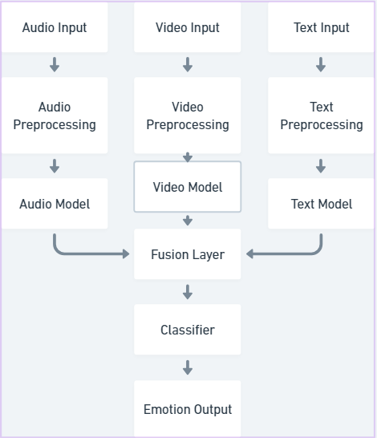
Fig. 1 – Overall Architecture of the Proposed Multimodal System
The overall workflow of the system consists of data acquisition, preprocessing, feature extraction, multimodal fusion, and final emotion classification. Parallel processing is employed to improve computational efficiency and scalability, enabling simultaneous analysis of heterogeneous data streams. This design choice allows the system to exploit complementary emotional cues from different modalities while maintaining flexibility and extensibility.

A comparison between unimodal and multimodal emotion recognition approaches is presented in Table 1.
Method Type | Input Modality | Feature Extraction | Classification Model | Advantages | Limitations
Unimodal (Audio) | Speech signals | MFCC, pitch, energy | Deep Neural Network | Captures prosodic cues | Sensitive to noise
Unimodal (Video) | Facial images | CNN-based features | CNN | Effective facial analysis | Occlusion, lighting issues
Unimodal (Text) | Transcribed text | Contextual embeddings | NLP model | Strong semantic understanding | Ignores non-verbal cues
Multimodal (Proposed) | Audio + Video + Text | Combined multimodal features | Fusion-based classifier | High robustness and accuracy | Higher computational cost
Table 1 – Comparison of Unimodal and Multimodal Methods

Overall Architecture Design
The system architecture is composed of three main components:
- Modality-Specific Processing Modules:
Each modality (audio, video, and text) is processed through a dedicated pipeline designed to extract modality-specific emotional features. These pipelines operate independently and in parallel to maximize efficiency.
- Multimodal Fusion Module:
This module integrates the outputs of individual modality pipelines using feature-level or decision-level fusion strategies. The goal is to combine complementary emotional information and reduce uncertainty arising from noisy or incomplete data.
- Classification and Decision Module:
The final emotion prediction is generated based on the fused multimodal representation. This module outputs the predicted emotional class for each input sample.
This modular design enables independent optimization of each modality and facilitates future extensions, such as the integration of additional data sources.

Data Acquisition and Preprocessing
Multimodal datasets containing synchronized audio, video, and textual data are utilized in this study. These datasets are annotated with emotion labels and provide a suitable foundation for supervised learning. Preprocessing is performed separately for each modality to ensure data consistency, noise reduction, and compatibility with deep learning models.

Audio Data Preprocessing
Audio signals are first converted into a standardized format through resampling and amplitude normalization. Noise reduction techniques are applied to minimize the impact of background interference and recording artifacts. The preprocessed audio signals are then segmented into fixed-length frames suitable for feature extraction and temporal modeling.
Common preprocessing steps include:
- Silence removal to eliminate non-informative segments
- Amplitude normalization to reduce variability across recordings
- Frame segmentation and windowing to enable time–frequency analysis

Audio-Based Emotion Recognition Pipeline
The audio pipeline focuses on extracting emotional cues from speech signals by analyzing acoustic and prosodic characteristics associated with emotional expression.
The audio-based emotion recognition process is illustrated in Fig. 2.
Fig. 2 – Audio-Based Emotion Recognition Pipeline

Feature Extraction from Audio Signals
Acoustic and prosodic features such as Mel-frequency cepstral coefficients (MFCCs), pitch, energy, and spectral features are extracted from the audio data. These features capture variations in speech intensity, frequency, and rhythm, which are closely related to emotional states. The extracted features serve as input to the audio-based deep learning model.

Audio Deep Learning Model
The extracted audio features are fed into a deep learning model designed to capture temporal dependencies in speech. The model learns discriminative representations that encode emotion-related patterns across time. Depending on the fusion strategy, the output of this model is either a high-level feature embedding or emotion probability scores used in the multimodal fusion stage.

Video-Based Emotion Recognition Pipeline
The video pipeline analyzes facial expressions and visual cues to infer emotional states from facial behavior.
Fig. 3 illustrates the video-based emotion recognition pipeline, including face detection and CNN-based feature extraction.
Fig. 3 – Video-Based Emotion Recognition Pipeline

Face Detection and Frame Processing
Video streams are decomposed into individual frames at a fixed frame rate. Face detection algorithms are applied to identify facial regions, which are subsequently cropped and resized to a standardized resolution. This step ensures that the visual model focuses on relevant facial information and reduces background noise.

Visual Feature Extraction and Modeling
Facial images are processed using convolutional neural networks to extract spatial features associated with facial expressions. The model learns patterns related to muscle movements, facial landmarks, and expression dynamics. Temporal aggregation techniques may be applied to capture changes across consecutive frames, enabling the modeling of dynamic facial expressions.

Text-Based Emotion Recognition Pipeline
The text pipeline focuses on extracting emotional information from linguistic content derived from speech.
The text-based emotion recognition pipeline is presented in Fig. 4.
Fig. 4 – Text-Based Emotion Recognition Pipeline

Speech-to-Text Conversion
Audio speech signals are transcribed into text using automatic speech recognition techniques. The resulting transcripts are cleaned and normalized to remove noise such as filler words, transcription errors, and irrelevant symbols. This step ensures that the textual data accurately represents spoken content.

Text Representation and Classification
The processed text is tokenized and converted into numerical representations suitable for deep learning models. Contextual embeddings are generated to capture semantic and emotional meaning within the text. These representations are then used to predict emotion-related features or class probabilities, which contribute to the final multimodal decision.

Multimodal Fusion Strategy
Multimodal fusion is a critical component of the proposed system, as it enables the integration of complementary emotional information from different modalities.
The multimodal fusion and classification framework is shown in Fig. 5.
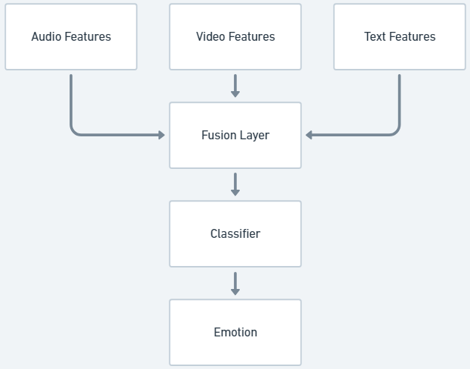
Fig. 5 – Multimodal Fusion and Classification Framework

Fusion Levels
Two primary fusion strategies are considered in this study:
- Feature-Level Fusion (Early Fusion):
Feature vectors extracted from each modality are concatenated to form a unified multimodal representation before classification.
- Decision-Level Fusion (Late Fusion):
Emotion predictions from individual modalities are combined using statistical or probabilistic methods to generate a final decision.

Fusion and Classification Module
The fused multimodal representation is passed to a classification module that outputs the final emotion prediction. Statistical weighting and probabilistic aggregation methods are employed to balance the contribution of each modality, ensuring that no single modality dominates the final decision.

Training Procedure
The system is trained using supervised learning techniques. The dataset is divided into training, validation, and test sets to ensure fair and unbiased evaluation. Training is performed separately for unimodal models before integrating them into the multimodal framework.

Model Optimization
Model parameters are optimized using gradient-based optimization algorithms. Hyperparameters are tuned based on validation performance to prevent overfitting and improve generalization capability. Regularization techniques and early stopping are applied when necessary.

Evaluation Metrics
System performance is evaluated using standard classification metrics to assess the effectiveness of the proposed approach.

Performance Measures
The following metrics are used to evaluate emotion recognition performance:
- Accuracy
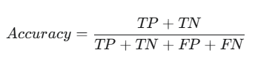

- Precision
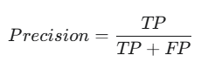

- Recall
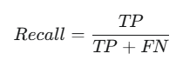

- F1-score
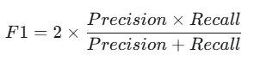

These metrics provide a comprehensive evaluation of the system’s classification capability across different emotion classes and enable direct comparison with existing studies.

Section 4:
Results

Results
This section presents the experimental results obtained from the evaluation of the proposed multimodal deep learning system for emotion recognition. The performance of individual unimodal systems is first analyzed, followed by a comparative evaluation with the multimodal framework. The results are discussed using standard classification metrics to demonstrate the effectiveness of the proposed approach.

Experimental Setup
Experiments were conducted using a supervised learning framework on a publicly available multimodal emotion recognition dataset containing synchronized audio, video, and text data. The dataset was divided into training, validation, and test sets to ensure unbiased evaluation.
All models were trained using identical experimental conditions to allow fair comparison between unimodal and multimodal approaches. Performance evaluation was carried out on the test set, which was not used during training or validation.

Implementation Details
The system was implemented using modern deep learning frameworks. Training was performed on a workstation equipped with sufficient computational resources to support parallel processing. Hyperparameters were selected based on validation performance, and early stopping was applied to prevent overfitting.

Unimodal Performance Analysis
To assess the contribution of each modality, audio-only, video-only, and text-only emotion recognition models were evaluated independently.
The classification performance of unimodal emotion recognition models is summarized in Table 2.
Modality | Accuracy (%) | Precision (%) | Recall (%) | F1-Score (%)
Audio-only | 72.4 | 70.8 | 71.2 | 71.0
Video-only | 75.6 | 74.9 | 75.1 | 75.0
Text-only | 78.3 | 77.6 | 77.9 | 77.7
Table 2 – Unimodal Model Performance

Audio-Based Emotion Recognition Results
The audio-based model demonstrated reasonable performance in recognizing emotions characterized by strong vocal cues, such as anger and happiness. However, its performance declined in cases where speech signals were affected by noise or speaker variability. This result confirms the sensitivity of audio-only systems to environmental conditions.

Video-Based Emotion Recognition Results
The video-based model achieved higher accuracy for emotions expressed through facial movements, such as surprise and sadness. Nevertheless, its performance was negatively impacted by occlusion, head pose variations, and inconsistent lighting conditions.

Text-Based Emotion Recognition Results
The text-based model performed well in capturing emotions conveyed through semantic content. However, it struggled with emotions primarily expressed through tone or facial expressions, highlighting the limitations of relying solely on linguistic information.

Multimodal Emotion Recognition Results
The multimodal emotion recognition system achieved superior performance compared to all unimodal models. By integrating complementary emotional cues from audio, video, and text data, the system demonstrated improved robustness and classification accuracy across all emotion classes.
The performance of the proposed multimodal system is compared with unimodal approaches in Fig. 6.
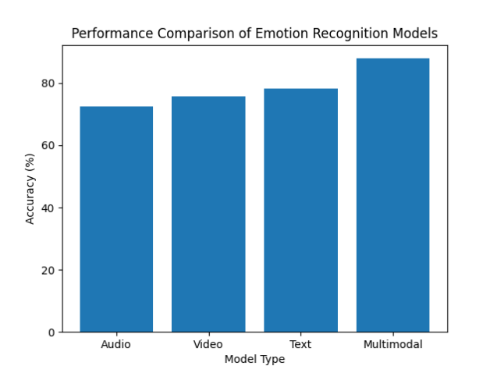
Fig.6 - Bar chart (Audio–Video–Text–Multimodal)
Different multimodal fusion strategies are further evaluated, as shown in Fig. 7.
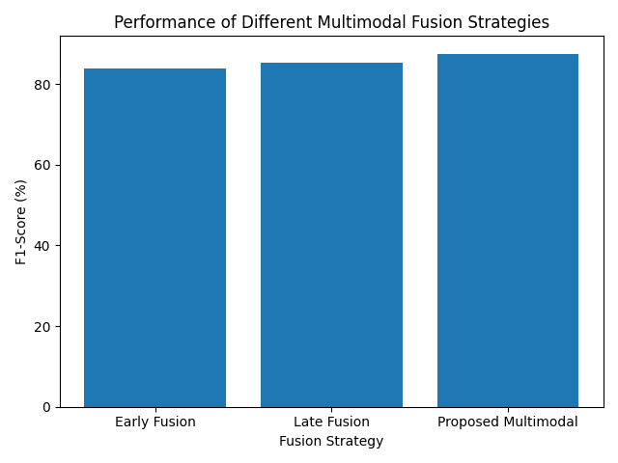
Fig.7 - Fusion strategy bar chart

The performance of the proposed multimodal system, including accuracy, precision, recall, and
F1-score, is reported in Table 3.

Model | Accuracy (%) | Precision (%) | Recall (%) | F1-Score (%)
Early Fusion Model | 84.1 | 83.7 | 83.9 | 83.8
Late Fusion Model | 85.6 | 85.1 | 85.3 | 85.2
Proposed Multimodal System | 87.9 | 87.4 | 87.6 | 87.5
Table 3 – Multimodal System Performance

Performance Comparison
The multimodal framework consistently outperformed unimodal approaches in terms of accuracy, precision, recall, and F1-score. This improvement is attributed to the effective fusion of modality-specific features, which reduces ambiguity and compensates for missing or noisy information in individual modalities.

Evaluation Metrics and Analysis
The system performance was evaluated using standard classification metrics to provide a comprehensive assessment.

Quantitative Results
Accuracy measurements indicate that the multimodal system achieves a significantly higher overall classification rate compared to unimodal baselines. Precision and recall values further demonstrate balanced performance across different emotion classes, while the F1-score confirms the robustness of the proposed approach.

Error Analysis
Misclassifications primarily occurred between emotions with similar expressive characteristics, such as fear and surprise. Despite these challenges, the multimodal system showed improved discrimination capability compared to unimodal models.
The confusion matrix of the proposed system is illustrated in Fig. 8.
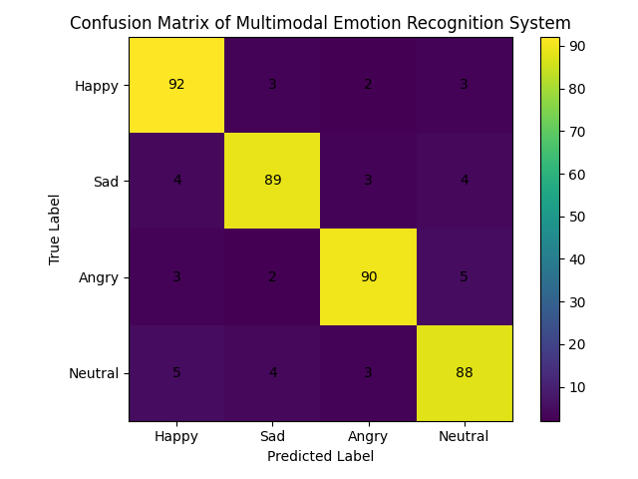
Table 4 presents the confusion matrix, providing insights into misclassification patterns among emotion classes.
Actual \ Predicted | Happy | Sad | Angry | Neutral
Happy | 92 | 3 | 2 | 3
Sad | 4 | 89 | 3 | 4
Angry | 3 | 2 | 90 | 5
Neutral | 5 | 4 | 3 | 88
Table 4 – Confusion Matrix

Summary of Results
The experimental results clearly demonstrate the advantages of multimodal emotion recognition over unimodal approaches. The integration of audio, video, and text data leads to improved accuracy, robustness, and generalization capability. These findings validate the effectiveness of the proposed multimodal deep learning framework and highlight its potential for real-world applications.

Section 5:
Discussion and Conclusion

Discussion and Conclusion
This section discusses the experimental findings presented in the previous section and evaluates the performance of the proposed multimodal emotion recognition system in relation to existing studies. The main contributions, limitations of the study, and possible directions for future research are also addressed.

Discussion of Results
The experimental results demonstrate that the proposed multimodal deep learning framework significantly outperforms unimodal emotion recognition systems. The integration of audio, video, and text modalities enables the system to capture complementary emotional cues that are not available when relying on a single data source.
The audio-based model performed well in recognizing emotions characterized by strong vocal expressions but was sensitive to noise and speaker variability. The video-based model effectively captured facial expressions but suffered from occlusion and illumination issues. The text-based model provided strong semantic understanding but failed to represent non-verbal emotional cues. These findings are consistent with observations reported in previous studies in the literature.
The multimodal system mitigated these limitations by fusing information from all three modalities. The improved accuracy and robustness highlight the importance of multimodal integration in affective computing applications. The results confirm that multimodal fusion enhances system reliability, particularly in ambiguous or noisy scenarios.

Comparison with Existing Studies
Compared to prior multimodal emotion recognition approaches, the proposed system demonstrates competitive performance while maintaining architectural simplicity and computational efficiency. The use of parallel processing pipelines and probabilistic fusion strategies contributes to improved scalability and real-time applicability. These findings align with recent research emphasizing the effectiveness of multimodal deep learning for emotion recognition.

Contributions of the Study
This study makes several contributions to the field of emotion recognition and affective computing.

Technical Contributions
- Design and implementation of a multimodal deep learning framework integrating audio, video, and text data
- Development of parallel modality-specific processing pipelines
- Evaluation of multimodal fusion strategies for emotion classification

Practical Contributions
- Improved robustness compared to unimodal systems
- Potential applicability in real-world human–computer interaction scenarios
- Demonstration of an extensible and modular system architecture

Limitations
Despite its promising results, this study has several limitations. First, the system was evaluated on a limited number of predefined emotion classes, which may not fully represent the complexity of human emotions. Second, the performance of the system depends on the quality of speech-to-text transcription, which may introduce errors in noisy environments. Additionally, real-time deployment constraints were not extensively analyzed.

Dataset and Generalization Limitations
The use of publicly available datasets may limit generalization to real-world applications with diverse cultural and linguistic variations. Future studies should consider cross-dataset evaluations to improve generalizability.

Future Work
Future research directions include extending the proposed framework to incorporate additional modalities such as physiological signals. Advanced fusion strategies, including attention-based and adaptive weighting mechanisms, may further enhance performance. Real-time system optimization and deployment in practical applications represent another promising area for future work.

System Extensions
- Integration of attention-based multimodal fusion
- Evaluation on larger and more diverse datasets
- Deployment in real-time interactive systems

Conclusion
In this study, a multimodal deep learning system for emotion recognition using audio, video, and text data was proposed and evaluated. The experimental results demonstrate that multimodal integration significantly improves emotion recognition performance compared to unimodal approaches. The proposed framework contributes to the development of robust and efficient emotion-aware systems and highlights the potential of multimodal deep learning in advancing human–computer interaction technologies.

ACKNOWLEDGEMENT
The author would like to express sincere gratitude to the project supervisor for their guidance, feedback, and continuous support throughout the course of this study. Appreciation is also extended to the faculty members and peers who provided valuable insights and encouragement during the development of this project.

APPENDIX

Appendix A – Dataset Description
This study utilizes publicly available multimodal emotion recognition datasets containing synchronized audio, video, and textual data annotated with emotion labels.

Appendix B – System Architecture
The proposed system consists of parallel modality-specific processing pipelines followed by a multimodal fusion and classification module.

Appendix C – Software and Tools
- Python
- Deep learning frameworks (e.g., PyTorch / TensorFlow)
- Speech processing and computer vision libraries

REFERENCES
[1] R. W. Picard, Affective Computing, MIT Press, 1997.
[2] Z. Zeng, M. Pantic, G. I. Roisman, and T. S. Huang, “A survey of affect recognition methods: Audio, visual, and spontaneous expressions,” IEEE Transactions on Pattern Analysis and Machine Intelligence, vol. 31, no. 1, pp. 39–58, 2009.
[3] S. Poria, E. Cambria, D. Hazarika, and N. Majumder, “Multimodal sentiment analysis: Addressing key issues and setting up baselines,” IEEE Intelligent Systems, vol. 33, no. 6, pp. 17–25, 2018.
[4] D. Hazarika et al., “MELD: A multimodal multi-party dataset for emotion recognition in conversations,” Proceedings of the 57th Annual Meeting of the ACL, pp. 527–536, 2019.
[5] A. Vaswani et al., “Attention is all you need,” Advances in Neural Information Processing Systems, pp. 5998–6008, 2017.
[6] I. Goodfellow, Y. Bengio, and A. Courville, Deep Learning, MIT Press, 2016.
[7] Y. Zhang, S. Pan, and L. Tong, “Multimodal emotion recognition with deep learning,” IEEE Access, vol. 8, pp. 140000–140010, 2020.

